# Integrating Simulated ChatGPT with a GUI – Solutions

## Modifying the Library Management System to incorporate the simulated ChatGPT

These exercises and code examples will help you understand the integration of backend logic (like a simulated ChatGPT) with a GUI frontend (using tkinter).

**Exercise 1**: **Problem**: Add a "Clear Chat" button to the Library Management GUI that clears the chat display when clicked.

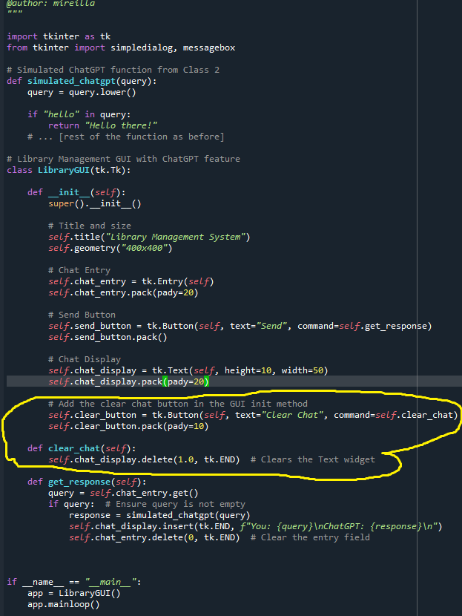

**Exercise 2**: **Problem**: Currently, the simulated ChatGPT only responds with static answers. Modify the function to provide a list of available programming books in the library when the user asks, "What books are available?"

We have simple list **available_books** that stores the titles of all available programming books. This exercise will teach you to dynamically fetch data and display it as a response in the chat, thereby making your simulated ChatGPT more interactive and data-driven.

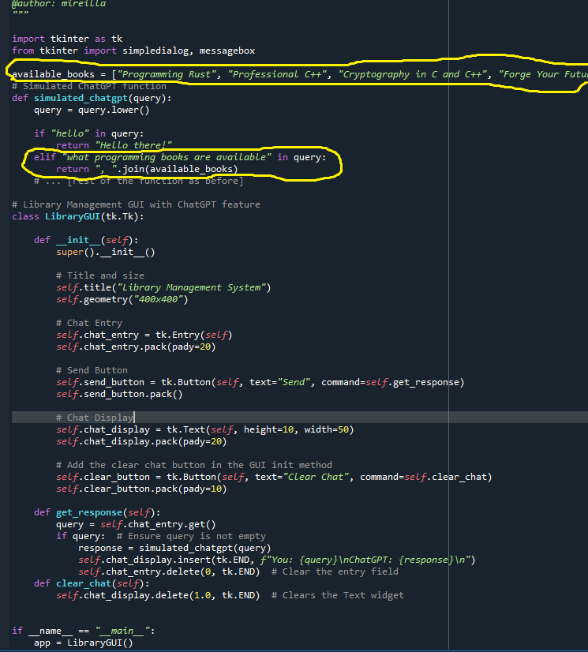

## Fetching Data from 'LibraryDB' and Incorporating it in ChatGPT

Update the code created in the previous exercise by completing the following exercises.

**Exercise 1**: **Problem**: Enhance the simulated ChatGPT to respond with the book's author when asked, "Who wrote [book_name]?"

**Exercise 2**: **Problem**: Add functionality to the simulated ChatGPT to return the number of available books when asked, "How many books are available?"

